

NYC Mobility Analytics Platform
Qeema Internship Project

Prepared by: Abdullah Mohamed Elsherif
Date: November 2026

1. Project Overview
The objective of this project was to build a data analytics platform using New York City High-Volume For-Hire Vehicle (HVFHV) trip data.
The project involved extracting raw trip data, cleaning and validating it, loading it into PostgreSQL, designing a data warehouse, performing SQL analysis, optimizing queries, and creating an interactive dashboard using Apache Superset.
The final platform allows users to explore trip activity, identify patterns, compare providers, and analyze pickup locations and trip characteristics.
2. Tools and Technologies Used
The following tools were used throughout the project:
- Python: Data extraction and ETL processing.
- Pandas: Data manipulation and transformation.
- PyArrow: Reading Parquet files.
- PostgreSQL: Database storage and management.
- SQL: Data analysis and query optimization.
- Apache Airflow: Pipeline validation and database monitoring.
- Apache Superset: Dashboard creation and visualization.
- Docker: Running the Superset and Airflow environments.
3. Data Extraction and ETL Process
The project used NYC TLC High-Volume For-Hire Vehicle trip records covering January 2025 to August 2026.
A total of 20 monthly Parquet files were downloaded, with an approximate combined size of 9.35 GB.
Python was used to process the files in batches. The ETL process consisted of three main stages:
3.1 Extraction
The monthly Parquet files were read using PyArrow. Instead of loading all records into memory at once, the process handled the data in smaller batches.
3.2 Transformation
The data was checked and validated before being loaded into the database.
The validation rules included:
- Checking for missing pickup and drop-off timestamps.
- Checking for invalid trip durations.
- Rejecting records with nonpositive trip times.
- Checking for missing or negative trip distances.
- Checking for missing pickup and drop-off location IDs.
- Identifying unusual fare and distance values using quality flags.
Records that failed the required validation rules were rejected. Other unusual values were flagged for further analysis.
3.3 Loading
The cleaned records were loaded into PostgreSQL.
The final ETL execution processed all 20 monthly files successfully.
Final ETL results:
Metric | Result
Monthly files processed | 20
Records loaded into staging | 411,760,137
Records loaded into fact table | 411,760,137
Rejected records | 16,258
Processing status | Completed
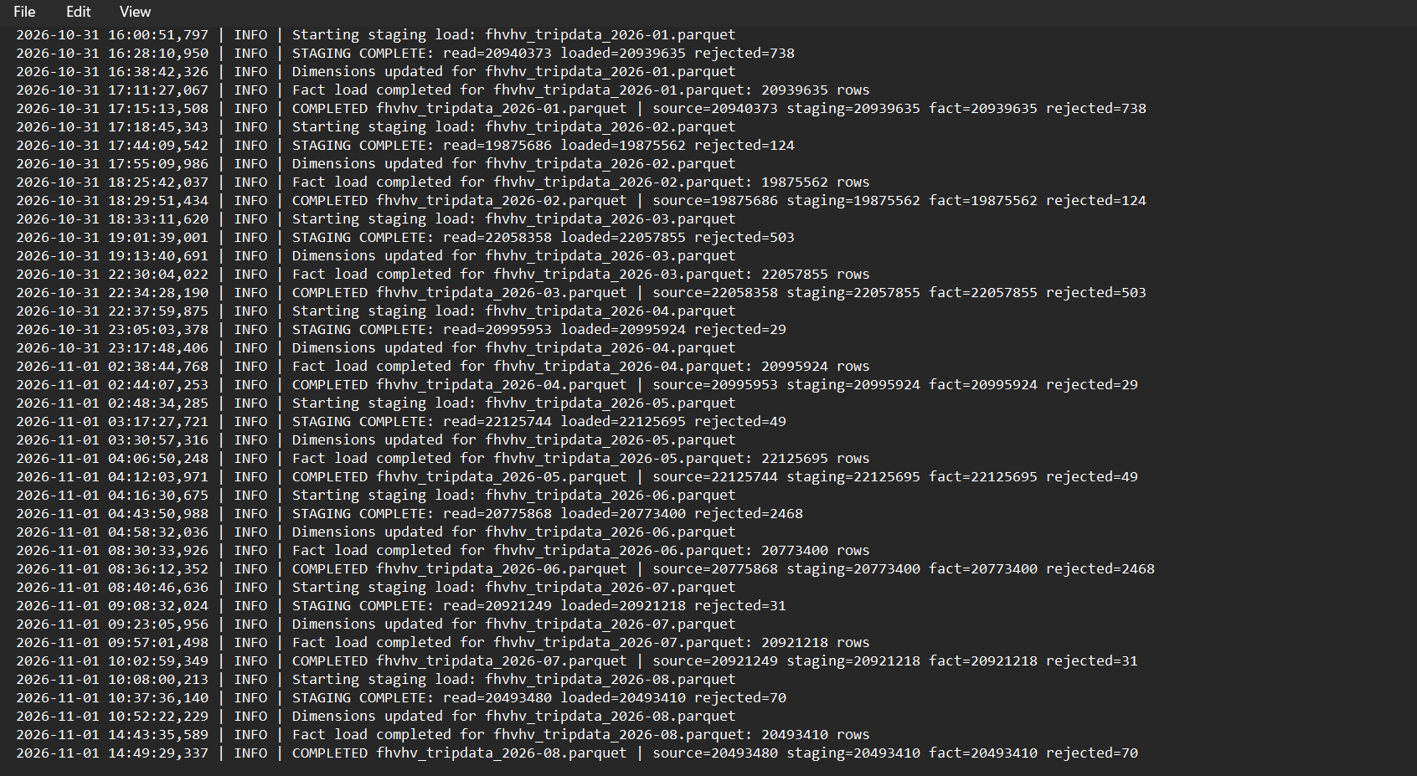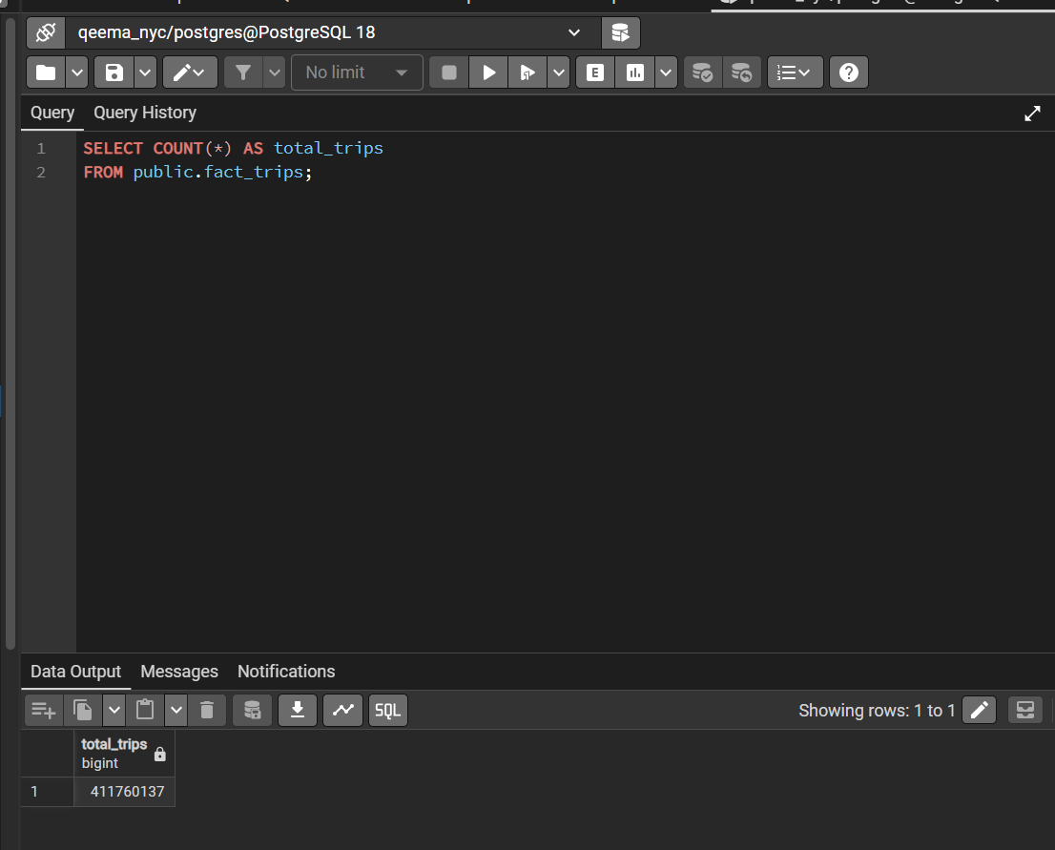
4. Database Design
PostgreSQL was used to store the processed data and support analytical queries.
A star schema was implemented to organize the data and make analysis easier.
The main fact table is fact_trips, which stores the trip records and connects to the dimension tables.
The dimension tables are:
- dim_date: Stores date-related information.
- dim_location: Stores pickup and drop-off location information.
- dim_license: Stores license-related information.
- dim_provider: Stores provider information.
The fact table contains the main trip measures, including trip distance, trip duration, fares, tips, and other trip-related values.
This structure makes it easier to analyze trips across different dates, locations, and providers.
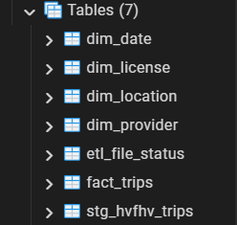

5. SQL Analysis
SQL was used to analyze the data and answer important business questions.
The analysis focused on monthly trip activity, pickup locations, borough performance, trip duration, providers, and tipping behavior.
5.1 Monthly Trip Volume
The monthly analysis was used to understand how trip demand changed over time.
A monthly summary was created to calculate the total number of trips for each month.
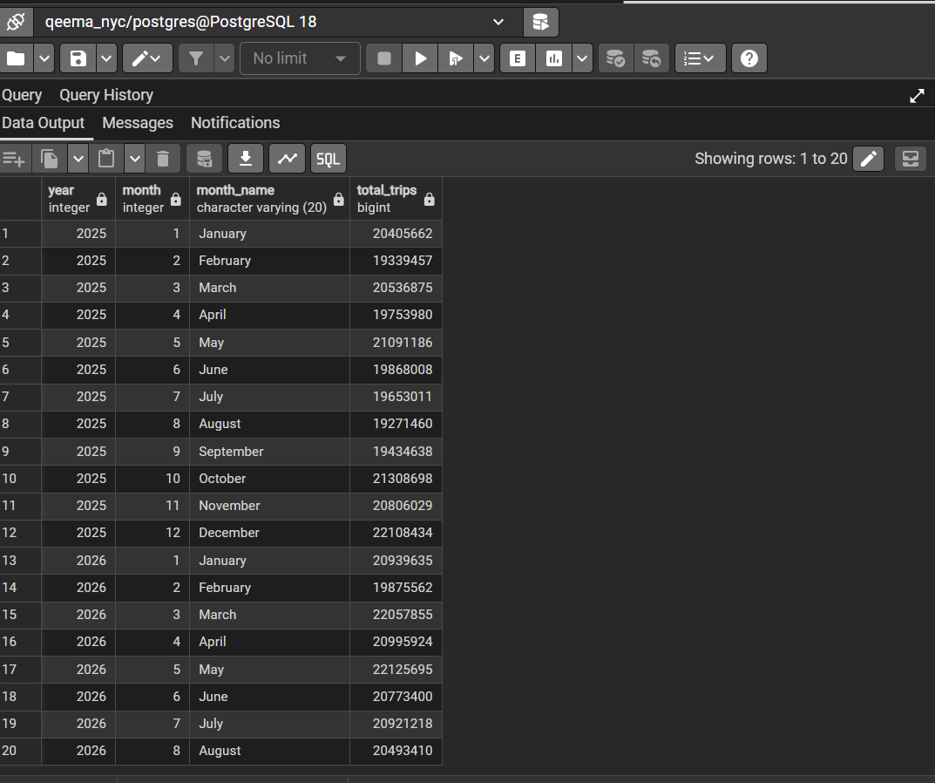
5.2 Pickup Location Analysis
The top 10 pickup locations were identified based on the total number of trips.
The results showed that LaGuardia Airport and JFK Airport were the two busiest pickup locations in the dataset.
5.3 Average Fare by Borough
The average base passenger fare was calculated for each borough.
Manhattan had the highest average fare among the major boroughs, at approximately $32.20, while the Bronx had the lowest, at approximately $19.71.
5.4 Trips by Day of the Week
The analysis showed that Saturday had the highest trip volume, with approximately 68.2 million trips. Monday had the lowest, with approximately 51.0 million trips.
This suggests that trip demand varies depending on the day of the week.
5.5 Trip Duration by Borough
The average trip duration was compared across boroughs.
Manhattan had the longest average trip duration among the major boroughs, at approximately 21.11 minutes.
Staten Island had the shortest, at approximately 15.84 minutes.
5.6 Trips by Provider
The provider analysis showed that two provider bases accounted for almost all trips in the dataset.
Provider B03404 represented approximately 72.21% of trips, while B03406 represented approximately 27.79%.
5.7 Trips by Hour
The hourly analysis showed that trip activity was highest around 6 PM, with approximately 24.1 million trips.
The lowest activity occurred around 3 AM.
5.8 Tip Analysis
Manhattan had the highest tipping frequency among the major boroughs, with approximately 24.47% of trips receiving tips.
The Bronx had the lowest tipping frequency, at approximately 7.90%.
These results provide a better understanding of passenger behavior and trip activity across different areas and times.
6. Performance Optimization
Performance optimization was important because the fact table contains more than 411 million records.
Two optimization techniques were implemented.
6.1 Materialized View
A materialized view called monthly_trip_summary was created to store precomputed monthly trip totals.
Before using the materialized view, the original aggregation query took approximately 142.90 seconds.
Reading the already calculated monthly summary took approximately 0.040 milliseconds in the measured test.
This demonstrates the benefit of storing frequently used aggregate results instead of recalculating them from the entire fact table every time.
The materialized view must be refreshed when the underlying data changes.
6.2 Database Indexing
An index called idx_fact_trips_pickup_date was created on the pickup_date_key column in the fact table.
The index was tested using a query that counted trips during January 2026.
The execution plan confirmed that PostgreSQL used a parallel index-only scan, with zero heap fetches. The query completed in approximately 2.07 seconds. 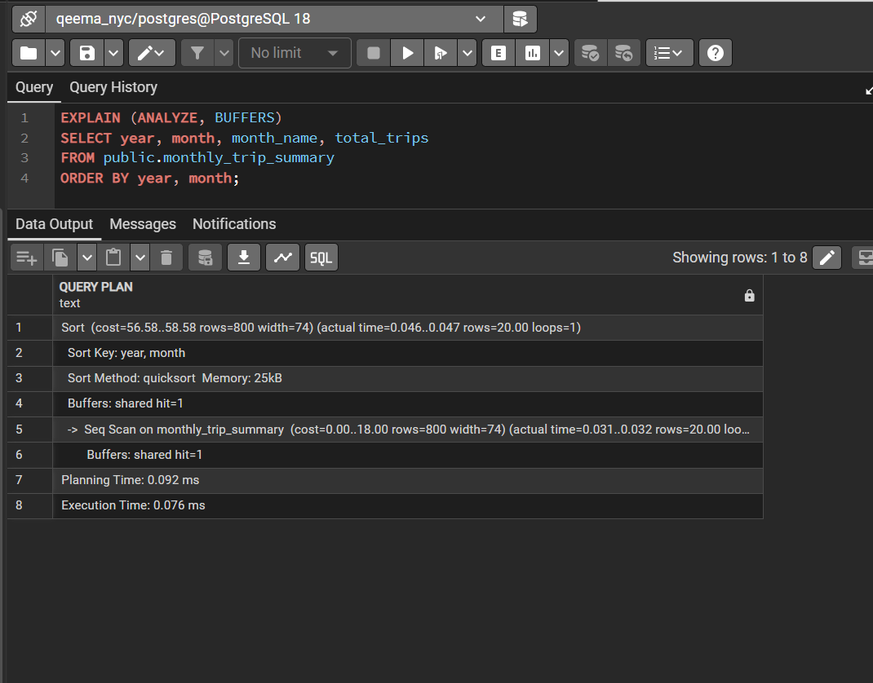
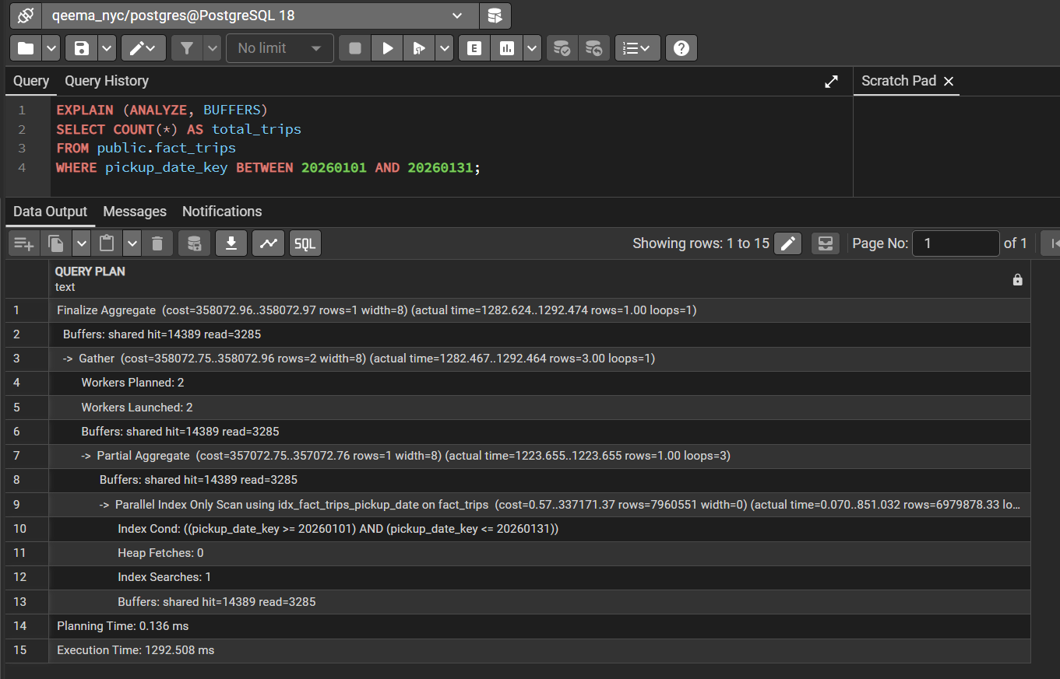
7. Apache Airflow
Apache Airflow was configured to monitor and validate the PostgreSQL database.
A DAG called nyc_mobility_pipeline was created with the following tasks:
- Start the workflow.
- Connect to PostgreSQL.
- Validate the database by checking the number of records in the fact_trips table.
The DAG executed successfully and confirmed that the fact table contained 411,760,137 records.
The Airflow workflow was used for database validation and monitoring. The main ETL loading process was executed separately using Python.
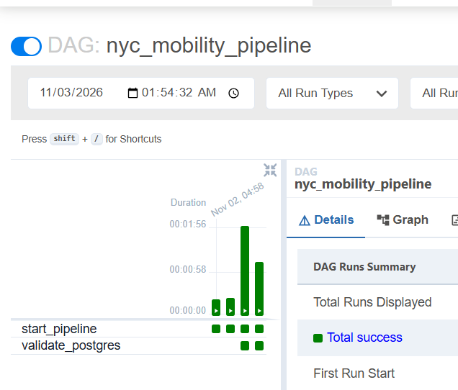
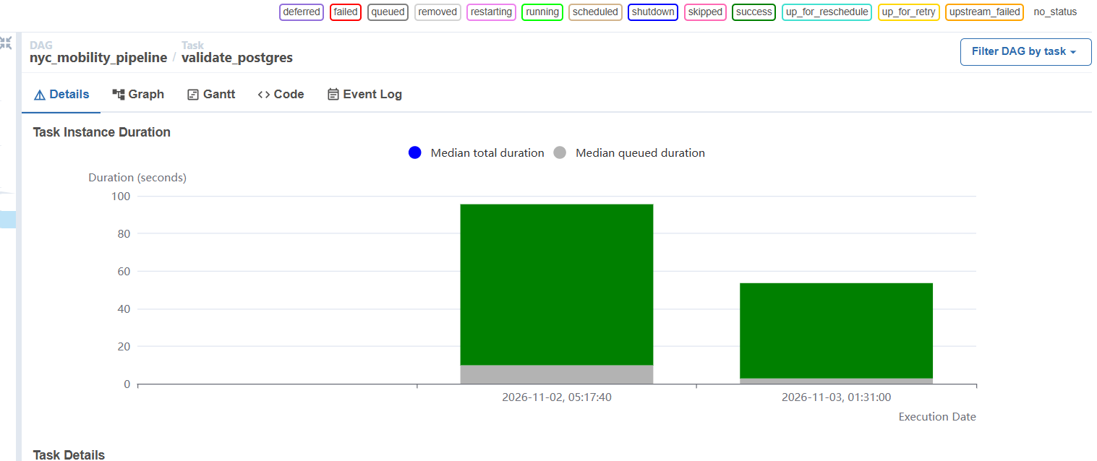
8. Dashboard Development
Apache Superset was used to create an interactive dashboard called NYC Mobility Analytics Dashboard.
The dashboard connects to the PostgreSQL database and presents the analysis through eight visualizations:
- Monthly NYC Trip Volume: Shows changes in trip demand over time.
- Top 10 NYC Pickup Locations: Identifies the busiest pickup locations.
- Average Fare by Borough: Compares average base passenger fares across boroughs.
- Trips by Day of Week: Shows how trip volume changes throughout the week.
- Average Trip Duration by Borough: Compares trip duration across boroughs.
- Trips by Provider: Shows the distribution of trips between providers.
- Trips by Hour: Identifies the busiest and quietest hours.
- Tip Analysis by Borough: Compares tipping frequency and average tips across boroughs.
The dashboard provides a visual overview of the dataset and makes the results easier to understand.
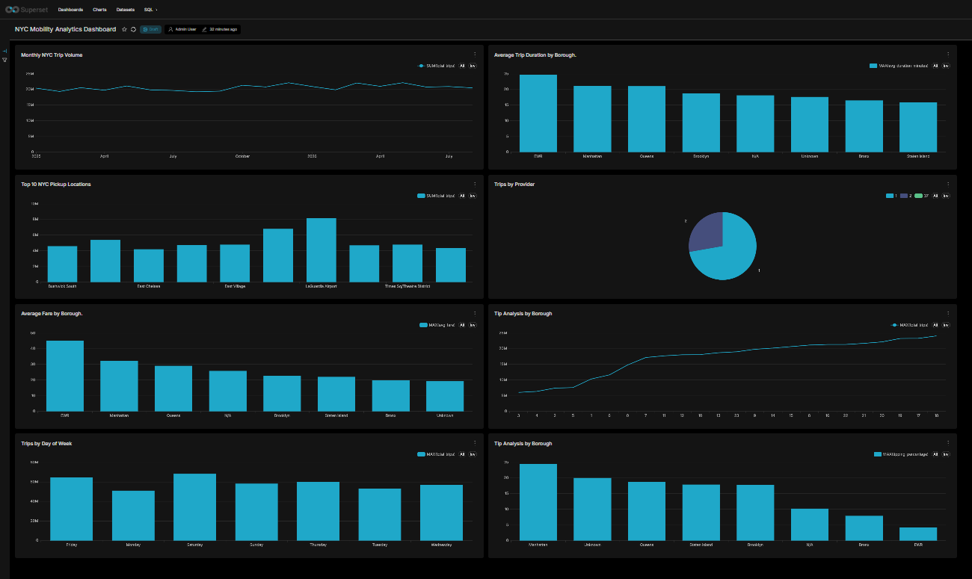

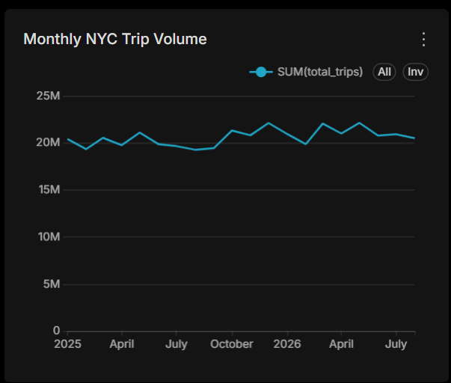
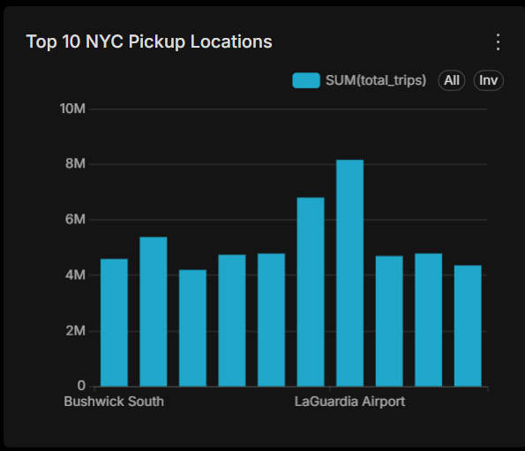
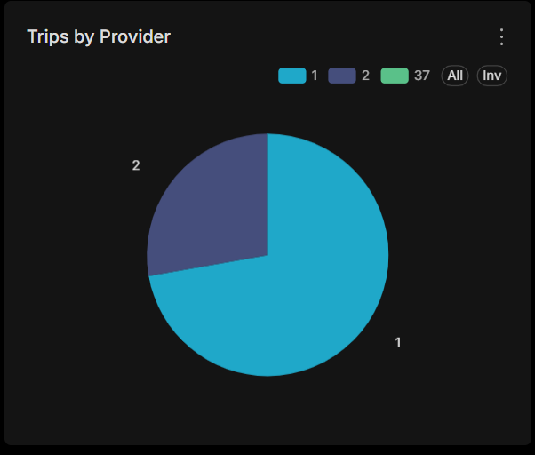
9. Conclusion
This project provided practical experience in building a data analytics platform using a large real-world dataset.
The work covered the main stages of a data engineering and analytics workflow, including data extraction, transformation, validation, database loading, dimensional modeling, SQL analysis, performance optimization, workflow validation, and dashboard development.
The final database contains more than 411 million processed trip records, and the Superset dashboard provides several views of NYC mobility patterns.
Overall, the project helped me understand how different data engineering and business intelligence tools work together to transform raw data into useful information for analysis and decision-making.

